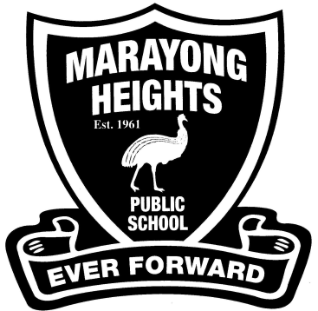  **Stage 1 (Years 1 and 2) – 2020**

**EQUIPMENT REQUIREMENTS**

Dear Parents and Carers,

We are asking that students have the following equipment ready for their new class.

Thank you,

Stage 1 teachers.

* *2 large glue sticks each term*
* *Library bag*
* *1 paint shirt, possibly with sleeves. An old one of yours is ideal.*
* *2 large boxes of tissues*
* *A4 Homework book ( approximately 64 pages)*
* *A spare pair of shorts, underpants and socks in a plastic bag can be kept in the child’s bag in case of accidents. (optional)*
* *2 rolls of paper towel (Optional)*
* *2 Whiteboard markers and an old sock as an eraser*
* ***Children may need to replace these essential items when required.***

C:\Users\Kirk Family\AppData\Local\Microsoft\Windows\Temporary Internet Files\Content.IE5\DXX1720C\MC900013019[1].wmf

*Please mark each item clearly with your child's name. Just a reminder that school hats are to be worn at school and these also need to be clearly labelled with your child’s name.*