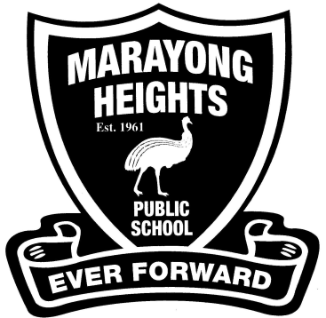  **Stage 2 (Years 3 and 4) – 2020**

**EQUIPMENT REQUIREMENTS**

Dear Parents and Carers,

We are asking that students have the following equipment ready for their new class.

Thank you,

Stage 2 teachers.

* *2 large glue sticks each term*
* *Library bag*
* *1 paint shirt*
* *2 large boxes of tissues*
* *2 red pens*
* *2 blue pens*
* *2 lead pencils, sharpener, eraser*
* *Pencil case with coloured pencils and textas*
* *2 rolls of paper towel (Optional)*
* *2 highlighters*
* *30cm ruler with ‘mm’ (wooden or plastic only)*
* *2 whiteboard markers and a sock to use as an eraser*
* ***Children may need to replace these essential items when required.***

C:\Users\Kirk Family\AppData\Local\Microsoft\Windows\Temporary Internet Files\Content.IE5\DXX1720C\MC900013019[1].wmf

*Please mark each item clearly with your child's name. Just a reminder that school hats are to be worn at school and these also need to be clearly labelled with your child’s name.*